**Setting up Python, PyCharm, and Selenium for Automated Testing**

1. Install the latest version of Python from this link, <https://www.python.org/downloads/>
2. When installing, ensure that the corresponding checkboxes are ticked
   1. Graphical user interface, text, application

      Description automatically generated
   2. Graphical user interface, text, application

      Description automatically generated
   3. Graphical user interface, text, application, chat or text message

      Description automatically generated  
      Also ensure that the install location is just like this but with the username corresponding to your own
3. Install the latest PyCharm IDE community edition from this link, <https://www.jetbrains.com/pycharm/download/#section=windows>
4. When installing, ensure that the corresponding checkboxes are ticked
   1. Graphical user interface, text, application, email

      Description automatically generated
5. The PyCharm install setup will ask you to restart your computer
6. It is recommended to use google chrome for selenium testing so ensure you have chrome installed and updated and Install the latest stable release of the chromedriver needed for selenium and select the win32 version from this link: <https://chromedriver.chromium.org/>
   1. Ensure chrome is on the latest version
   2. Graphical user interface, text, application

      Description automatically generated with medium confidence
   3. Graphical user interface, application, table

      Description automatically generated
7. This will download a zipped folder, unzip it using 7zip
   1. There will be a single chromedriver.exe file after you unzip it, you will need this later
8. Navigate to your windows search bar and type in “Command Prompt”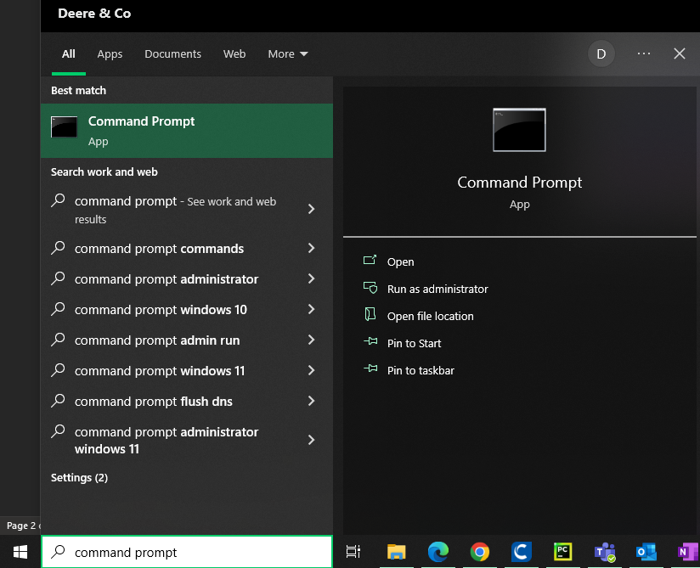
9. Type in cd C:\Users\ebu312q\AppData\Local\Programs\Python\Python310\Scripts but replace “ebu312q” with your own username and press enter

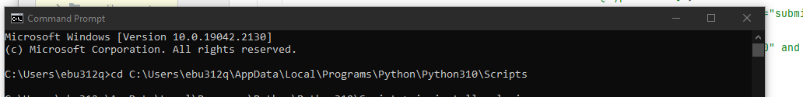

1. Next type in and press enter for each of these commands one by one. After each installation, the last line of each message should state something like “successfully installed xxx” or “requirement already satisfied” (which is fine since it means it was already installed)
   1. pip install selenium
   2. pip install webdrivermanager
   3. pip install webdriver-manager
   4. pip install pandas
2. if asks you to upgrade pip, feel free to do that as well and type it in exactly as it prompts you “python.exe -m pip install --upgrade pip”
3. After installing those 4 packages, next type in “pip list” and check to make sure the 4 packages are in the list

1. Next launch PyCharm and click on “New Project”

1. Next name the project in the upper line as “SeleniumPython” and make sure to click on the checkbox for “Inherit global site-packages” and click “Create”

1. After you click “Create” a new project will be made and you will be greeted to the main coding interface.
2. Navigate to File -> Settings

1. Go to “Project: SeleniumPython” and then Python Interpreter

1. Ensure that all the packages you installed previously are listed here. If they are not, then click on the plus icon
2. Type in the search bar the name of the package, click on the respective one, and then click the specify version checkbox and type in the version that appears in the description box. Then click “Install Package.” Click “OK” after finishing

1. Right click on the “SeleniumPython” folder in the upper left corner and select “New” then “Directory.” Name it “Drivers”

1. Navigate to where you downloaded the chromedriver.exe file and then drag it into the “Drivers” folder

1. Select and drag the python script files, CommonMHMethods.py, CreateData.py, ElementsDict, ExportScriptResults.py, and UpdateASNReferenceField.py into the Selenium Python folder
2. There are three lines of code where you will need to change the file location, replacing “ebu312q” to your username
   1. In the UpdateASNReferenceField.py, 
   2. In the ExportScriptResults.py





1. In the UpdateASNReferenceField.py file, in the main method, you can change the environ variable to either “DEVL” or “PROD”
   1. 
   2. If you set the environment to “DEVL,” it will bring you to the login screen, where you will be given 30 seconds to login manually. After entering your password and the main screen pops up, the script will continue.
   3. If you set the environ to “PROD,” it will skip the above step and bring you the main screen and the script will continue
2. Before running the script, create two blank folders in your documents location (C:\Users\username\Documents) called “Selenium Script Results” and “Screenshots.” Also create an excel file called “update_trailer_reference_field_asns.xlsx”
   1. Text

      Description automatically generated
3. In that excel file, call the first column “ASNs” and “Trailer Num.” List out the asns and trailer numbers you want in the respective columns, and save.
   1. Table

      Description automatically generated
4. To run the script, navigate to the UpdateASNReferenceField.py file on the left side and right click, and click “Run”
   1. Graphical user interface, text, application, email

      Description automatically generated
5. When running the script, it will create a new browser session that is run the background allowing you to continue other work while the script runs. It will also print out statements in the Pycharm console describing what it is currently doing. After it finishes running, it will export an excel file to your Selenium Script Results folder in your documents folder with its respective date and time.
6. In the results file there will be 3 sheets, Test Results, Data, and Screenshot
   1. Test Results will list out each step that the script performed and if it passed with detail as to which element on screen it was interacting with. If the script times out, it will still export an excel file and the last step listed in the Test Results sheet was the last step it did.
   2. The Data tab lists out the asns, trailers, and whether it passed successfully
   3. The Screen shot tab displays a screenshot of the last thing the script saw in the browser before ending